**Project Name : Weight measurement system using arduino**

**Description :**

We are going to build an arduino weighing machine, by interfacing Load Cell and HX711 Weight Sensor with Arduino. We have seen weight machines at many shops, where the machine displays the weight just by placing an item on the weighing platform. So here we are building the same Weighing machine by using Arduino and Load cells, having a capacity of measuring up to 40kg. This limit can be further increased by using the Load cell of higher capacity. The main component required to build this Arduino weighing scale is a sensor that can convert weight into an equivalent electrical signal. This sensor is called as the **load cell**, so in this project, we will using this load cell as our Arduino weight sensor.

The Arduino coding will be done using arduino IDE for ubuntu .To run the required arduino code in arduino IDE in Ubuntu, We need to complete some more steps.

1. Open terminal
2. $ sudo apt update –y && apt upgrade –y
3. $ mkdir arduino && cd arduino
4. $ wget <https://downloads.arduino.cc/arduino-1.8.15-linux64.tar.xz>
5. $ tar -xvf ./arduino-1.8.15-linux64.tar.xz
6. $ cd arduino-1.8.15/
7. $ sudo ./install.sh

In these steps, We will be ready to use our arduino IDE and simulate it.

**Required Equipments and estimated cost:**

* **Arduino Uno :1045/-**
* **Arduino Uno** is a microcontroller board based on the ATmega328P. It has 14 digital input/output pins (of which 6 can be used as PWM outputs), 6 analog inputs, a 16 MHz ceramic resonator (CSTCE16M0V53-R0), a USB connection, a power jack, an ICSP header and a reset button. It contains everything needed to support the microcontroller
* **Load cell : 300/-**
* A load cell is a transducer that is used to create an electrical signal whose magnitude is  
  directly proportional to the force being measured. It is basically a device that measures  
  strain and then converts force into electric energy which serves as a measurement for  
  scientists and workers. The strain measurement by load cells helps in maintaining the  
  integrity of the unit under pressure and protects people and equipment nearby.
* **HX711 Load cell Module : 225/-**
* The Load Cell Amplifier is a small breakout board for the HX711 IC that allows you to easily  
  read load cells to measure weight. By connecting the amplifier to your microcontroller you  
  will be able to read the changes in the resistance of the load cell, and with some calibration,  
  you’ll be able to get very accurate weight measurements.  
  The HX711 uses a two‐wire interface ﴾Clock and Data﴿ for communication. Any  
  microcontroller’s GPIO pins should work, and numerous libraries have been written, making  
  it easy to read data from the HX711. Check the hookup guide below for more information.  
  Load cells use a four‐wire Wheatstone bridge configuration to connect to the HX711. These  
  are commonly colored RED, BLK, WHT, GRN, and YLW. Each color corresponds to the  
  conventional color coding of load cells:
* **Red (Excitation+ or VCC)  
  Black (Excitation‐ or GND)  
  White (Amplifier+, Signal+ or Output+)  
  Green ﴾A‐, S‐ or O‐﴿  
  Yellow (Shield)**
* **16x2 LCD :220/-**

- For display purpose

* Connecting wires : 95/-
* USB cable : 90/-

TOTAL COST : 2000

**Circuit layout:**

Connections for this project is given below.

16x2 LCD pins RS, EN, d4, d5, d6, and d7 are connected with pin numbers 8, 9, 10, 11, 12, and 13 of Arduino respectively. HX711 Module’s DT and SCK pins are directly connected with Arduino's pins A0 and A1. Load cell connections with the HX711 module are already explained earlier and also shown in the below circuit diagram.

**Schematic Diagram:**

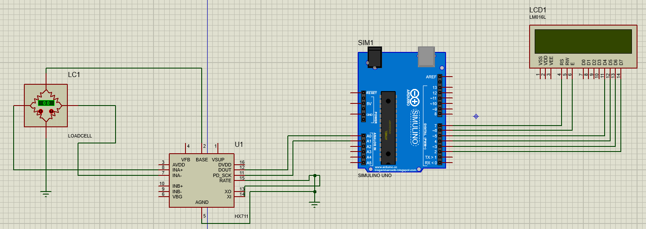

**Procedure :**

**Load Cell and HX711 Weight Sensor Module:**

The load cell is a transducer that transforms force or pressure into electrical output. The magnitude of this electrical output is directly proportional to the force being applied. Load cells have a strain gauge, which deforms when pressure is applied to it. And then strain gauge generates an electrical signal on deformation as its effective resistance changes on deformation. A load cell usually consists of four strain gauges in a Wheatstone bridge configuration. Load cell comes in various ranges like 5kg, 10kg, 100kg and more, here we have used Load cell, which can weigh up to 40kg.

Now the electrical signals generated by the Load cell are in few millivolts, so they need to be further amplified by some amplifier and hence HX711 Weighing Sensor comes into the picture. HX711 Weighing Sensor Module has HX711 chip, which is a 24 high precision A/D converter (Analog to digital converter). HX711 has two analog input channels and we can get gain up to128 by programming these channels. So HX711 module amplifies the low electric output of Load cells and then this amplified & digitally converted signal is fed into the Arduino to derive the weight.

The load cell is connected with the HX711 Load cell Amplifier using four wires. These four wires are Red, Black, White, and Green/Blue. There may be a slight variation in the colors of wires from module to module. Below the connection details and diagram:

RED Wire is connected to E+

BLACK Wire is connected to E-

WHITE Wire is connected to A-

GREEN Wire is connected to A+

Fixing Load Cell with Platform and Base:

it’s better to attach a platform for putting the large things on it and fix it on a Base so that it standstill. So here we need to make a frame or platform for putting the things for weight measurement. A base is also required to fix the load cell over it by using nuts and bolts. Here we have used hard cardboard for the frame for placing things over it and a wooden board as a Base. Now do the connections as shown in the circuit diagram and you are ready to go.

**Working Explanation:**

The working principle of this Arduino Weight Measurement project is easy. Before going into details, first, we have to calibrate this system for measuring the correct weight. When the user will power it up the system will automatically start calibrating. And if the user wants to calibrate it manually then press the push button. We have created a function void calibrate() for calibration purposes, check the code below.

For calibration, wait for LCD indication for putting 100 gram over the load cell as shown in the below picture. When LCD will show “put 100g” then put the 100g weight over the load cell and wait. After some seconds the calibration process will be finished. After calibration user may put any weight (max 40kg) over the load cell and can get the value over LCD in grams.

In this project, we have used Arduino to control whole the process. Load cell senses the weight and supplies an electrical analog voltage to HX711 Load Amplifier Module. HX711 is a 24bit ADC, which amplifies and digitally converts the Load cell output. Then this amplified value is fed to the Arduino. Now Arduino calculates the output of HX711 and converts that into the weight values in grams and shows it on LCD. A push-button is used for calibrating the system.